**Ideation Phase**

**Define the Problem Statements**

|  |  |
| --- | --- |
| Date | 19 September 2022 |
| Team ID | PNT2022TMID44442 |
| Project Name | Fertilizer Recommendation system For Disease Prediction |
| Maximum Marks | 2 Marks |

**Customer Problem Statement:**

Customer can be develop the good grows crop and facing the issue of the plant disease Farmer Are The First Customer For This Application. Farmer Can Easily Use This Application And Get Suggestion For Fertilizer To Used Correctly. Availability of good networks.Capturing the image in a required pixels to get a accurate prediction of disease in the plant.

Reference: <https://miro.com/templates/customer-problem-statement/>

**Example:** 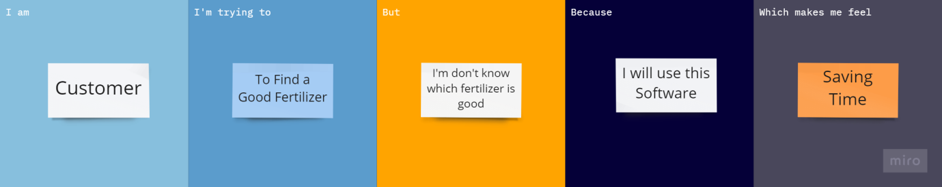

|  |  |  |  |  |  |
| --- | --- | --- | --- | --- | --- |
| **Problem Statement (PS)** | **Iam (Customer)** | **I’m trying to** | **But** | **Because** | **Which makes me feel** |
| PS-1 | Customer | Good fertilizer | Don’t cure  theDisease | Using this system | Saving time |
| PS-2 | Customer | Grows goods crops | Fertilizer not good | Developing this project | Useful for farmers |